
SHIRE HIGHLANDS EDUCATION DIVISION
2026 MALAWI SCHOOL CERTIFICATE OF EDUCATION MOCK EXAMINATION
GEOGRAPHY
PAPER 1
(100 MARKS)

MARKING KEY
1. Map extract of Madisi.
a. 702134 2 marks
b. Trigonometrical station 1 mark
c. North 1 mark
d. 4550ft 1 mark
e. Dendritic 1 mark
f. 9 kilometres 2 marks
g. Not intervisible, because there is a raised ground between them. 2 marks
h. 012ﹾ 2 marks
i. Number of full squares at the western road side = 69 1 mark
Number of part squares at the western road side = 49 1 mark
Total number of full squares = 69+(48/2)
= 69+24
= 93 squares 1 mark
Area of 1 square = 1km*1km
= 1 sq km 1 mark
Area of western side of the main road = 1sq km*93 squares
= 93 sq km 1 mark

2. a. (i) -sudden movements of the earth
- vibrations in the lithosphere.
Any one point 2 marks
(ii) -the crustal rocks grid against each other as plates slip past one another.
-Rocks along a fault may lock together causing pressure to build up over time, and then the rocks may jerk free thereby releasing shock waves.
Any one point 2 marks
(iii) -mining
-nuclear testing
-road construction
Any two points 1 mark each
b. (i) -hail
-snow
-sleet
Any two points 1 mark each
(ii) -is wide spread
-is of a longer duration
-occurs in the mountain on the windward side
Any two points 1 mark each
c. (i) B – Maritime Equatorial (mE) 1 mark
C – Continental Arctic (cA) 1 mark
(ii) A is cold while B is warm 1 mark
A is dry while B is very moist 1 mark
(iii) The regions has stable air because of high pressure (cold and dry air mass)
d. (i) - occluded (cold occluded ) front
Any one point 1 mark
(ii) 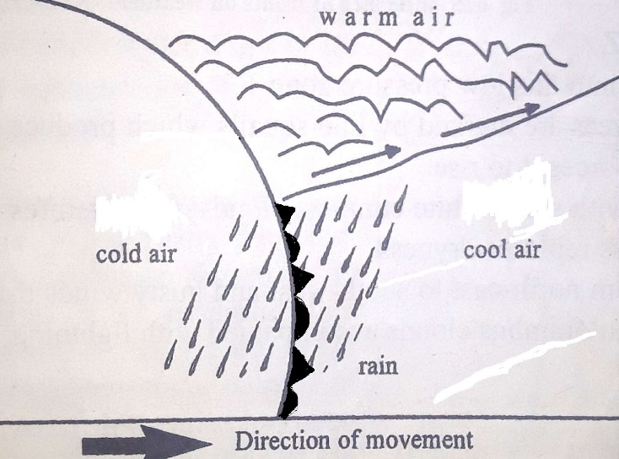 2 marks
(iii) 2 marks
(iv) -settled weather (calm clear settled weather)
Any one point 1 mark each
(v) -temperature
-altitude
-amount of water vapour in the air
-the volume that the air takes up
Any two points 1 mark each
3. a (i) -Africa
-South America
Any two points 1 mark each
(ii) -subduction (dipping of the earth’s surface into the deeper parts
-extrusion (upwelling of material from inside the earth to the surface
Any two points 1 mark each
(iii) -permits ore-forming chemical solutions to rise along fault planes
-valleys may form broad lowlands to provide rich agricultural lands
-cold and hot springs are situated along fault lines
-fault scraps may form topographic barriers
-petroleum finds its way along fault planes
Any two points 1 mark each
(iv) -variations in thickness of sediments on the ocean floor
-variations in age of sediments on the ocean floor
-variations in age of rocks in the ocean floor
-magnetic variations on the ocean floor (palaeomagnetism)
Any two points 2 marks each
b. (i) -convergent plate boundary (constructive plate boundary)
Any 1 point 1 mark each
(ii) -trench
-volcanic mountains
-fold mountains
-earthquakes
Any two points 1 mark each
c. (i) -burning fossil fuels such as coal, natural gas and oil which accumulate in the atmosphere
-deforestation; when trees are cleared or burned, the carbon stored in the trees is released into the atmosphere as carbon dioxide, adding to the greenhouse effect.
-increased agricultural activities e.g. raising livestock e.g. cattle creates large quantities of carbon dioxide and methane emissions.
-urbanization tall buildings and fly overs may reduce the free flow of air, causing climate change.
-rapid population growth leads to greater consumption of food, water and energy putting a great stress on environment
Any two points 2 marks each
(ii) -enhanced financial and technical support to the agricultural communities so that indigenous and more drought tolerant food crops like cassava, millet, sorghum can be re-introduced into the farming system
-promoting irrigated agriculture by developing irrigation schemes along river basins, construction of water basins and pans
-addressing land degradation by building soil and stone bunds, creating grass strips and contour levelling as well as incorporating trees or hedgerows
-creating functional linkages with development partners for technological enterprise initiatives
-diversifying rural economies e.g. through value addition to the agricultural products and financial support for apiculture with the aim of reducing reliance on climate-sensitive agricultural practices.
-reducing reliance on centralized food system where commodity production is concentrated in a few locations that may be vulnerable to climate disruptions such as storm damage
-switching to new crops, seeds or agricultural practices can moderate the impacts on agriculture of changes in temperature and water availability
-improving weather and flood forecasting and communications can assist evacuation, relief and rehabilitation
Any two points 2 marks each.
(iii) -reduced agricultural land
-poverty and underdevelopment; Malawi is importing more food supplies than it is exporting to offset the increasingly serious effects of desertification
-depletion of water sources; loss of vegetation to desertification results in little rainfall
-loss of biodiversity; desertification contributes to the destruction of the habitats of animal and vegetable species and micro-organisms
-increased flooding; as protective plant cover disappears due to desertification
-increased illiteracy rates among women; women fail to attend to schools, job training or even leisure because they walk long distances to fetch water and collect firewood
-increased urbanization rates; many Malawians are leaving rural areas to urban centers to look for a better life
-climate change; increase in average temperatures and unpredictable rains are seriously affecting the country’s agriculture sector and this is affecting many lives
Any two points 2 marks each
4. a (i) -cool temperate interior (siberian) climate
Any one point 1 mark each
(ii) -coniferous forest
Any one point 1 mark
(iii) -Alaska
-Norway
-Finland
-Siberia
Any two points 1 mark each
(iv) -extreme temperature range (as cold as 50ﹾC in winter, up to 20ﹾC in summer)
-low precipitation (mostly snow in winter)
-high pressure systems dominate bringing clear weather
Any two points 2 marks each
b. (i) -prevents diseases like cholera and malaria
-environmental protection ie reduce pollution of water, soil and air
-aesthetic and tourism value -clean streets attract tourists and improve quality of life
-prevent flooding - clipped drains and blocked waterways can cause floods
Any two points 2 marks each
(ii)
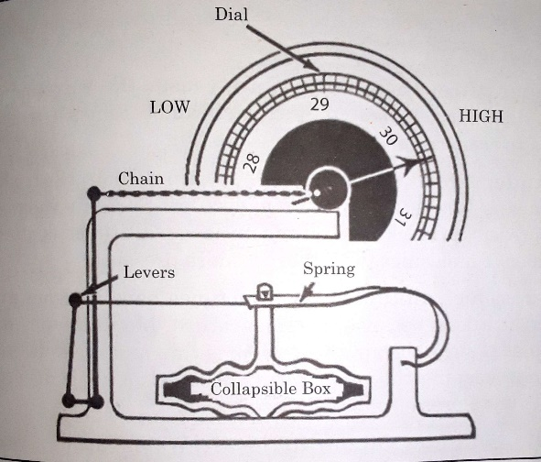
3 marks
The increase in air pressure on the outside of the box makes the lid to move inwards. The chain is pulled to the right. This makes the indicator to the right as well to register high pressure. When pressure falls, the box lid outward, and the indicator (pointer) moves to the left to show pressure.
Any correct explanation 3 marks
(iii) when igneous rock breaks into small particles, these particles are washed away and deposited in geosyncline where they are compacted and cemented to form sedimentary rock.
Any one point 4 marks
(iv) -because of cyclical deposition of sediments
Any correct answer 2 marks
(v) - clouds of great vertical extent
Any correct answer 1 mark
5. a. (i) global warming can make some areas warmer and some areas drier
-more evaporation
-shift in wind pattern can bring droughts
-extreme weather like intense storms or prolonged droughts become more likely
Any correct answer 2 marks each
(ii) -an abundant source of warm moist air of temperature of about 27ﹾC near to sea surface
-air must be blowing inwards towards the centre and rising rapidly and nimbocumulus clouds must form to give heavy rains.
-there must be an inward flow of air in the upper level of the atmosphere
Any two correct answers 1 mark each
(iii) -it is associated with calm weather with light winds and no rain
Any correct answer 2 marks
(iv) -the affected areas are marked by line squalls which produce turbulent and drier hotter air and forces it to rise
-the skies fill with small white cumulus clouds, temperatures drop slightly and a warm moistness replace dryness
-winds veer from north-east to south-west and gusty winds bring rain showers
-gradually cumulonimbus clouds accompanied with lightning, thunder and heavy rains develop
Any two correct answers 1 mark each
b. (i) -Labrador cold ocean current
-North Atlantic Drift warm current
Any two correct answers 1 mark each
(ii) -it has lead to development of a major fishing ground because these areas have rich deposition of nutrients
-upwelling; deep nutrient-rich water rises
-fog is created and influence local climates
Any two correct answers 2 marks each
c. (i) -tropical continental climate (Savanna/Sudan climate)
Any correct answer 1 mark each
(ii) -alternating hot,rainy season and cool, dry season.
-the monthly temperatures are from 21ﹾC to 32ﹾC. the annual temperature range of 11ﹾC is typical
-the vegetation is tall grass with short scattered trees which form a parkland or bush veld.
Any two correct answers 2 marks each
(iii) -Sudan
-Malawi
-Kenya
-South Africa
Any two correct answers 1 mark each
(iv) -droughts which can be serious most of the time.
-leaching which leads to formation of poor lateritic soils
-tsetse flies which do not favour animal rearing.
Any two correct answers 1 mark each.
(v) -to prevent water loss through transpiration.
Any one correct point 2 marks each

